**COMMUNITY: ANMAL WELFARE**

**ELECTED BARANGAY OFFICIALS 2018-2022**

Barangay Captain: Maribel A. Estacion

KAGAWAD:

Emilia F. Ocon

Committee Chairman on Livelihood and Employment

Josefina D. Ferrer

Committee Chairman on Health & Nutrition and Protection of Children

Augusto G. Abat

Committee Chairman on Ecological & Environmental Management

Dionisio B. Hadasan Jr.

Committee Chairman on Housing and Land Issues

Jacinto D. Lanozo

Committee on Peace and Order and Public

Corazon M. Narciza

Committee Chairman on Appropriation and Infrastructure Development

Abraham C. Tadeo

Committee Chairman on Ways and Means Clearing Document and Property

Secretary: Hilaria D. Sawad

Treasurer: Fely B. Isnac

Total population: **4,825**

Activities:

1. Free rabies vaccination every year

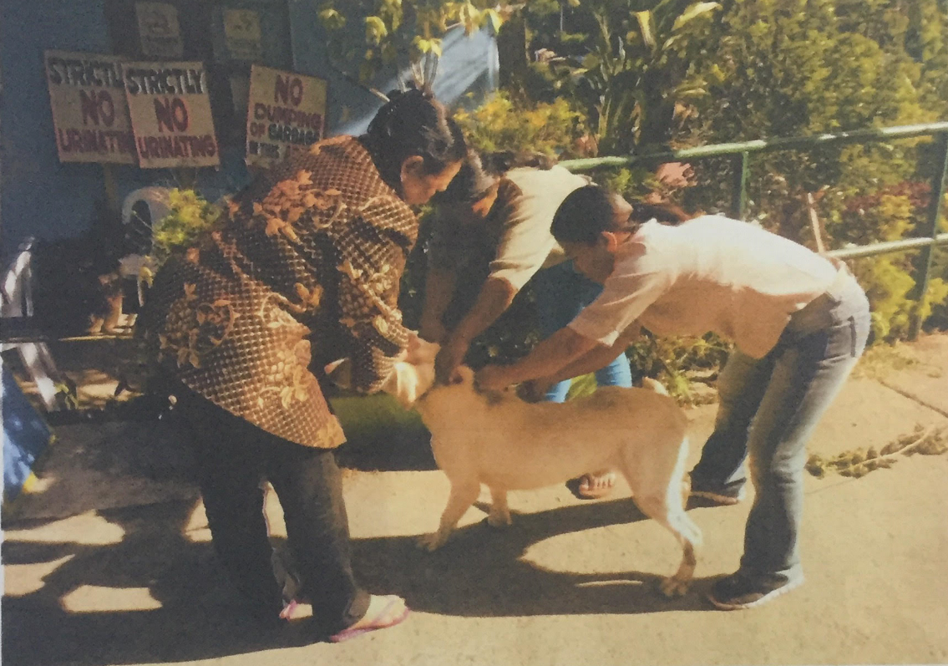

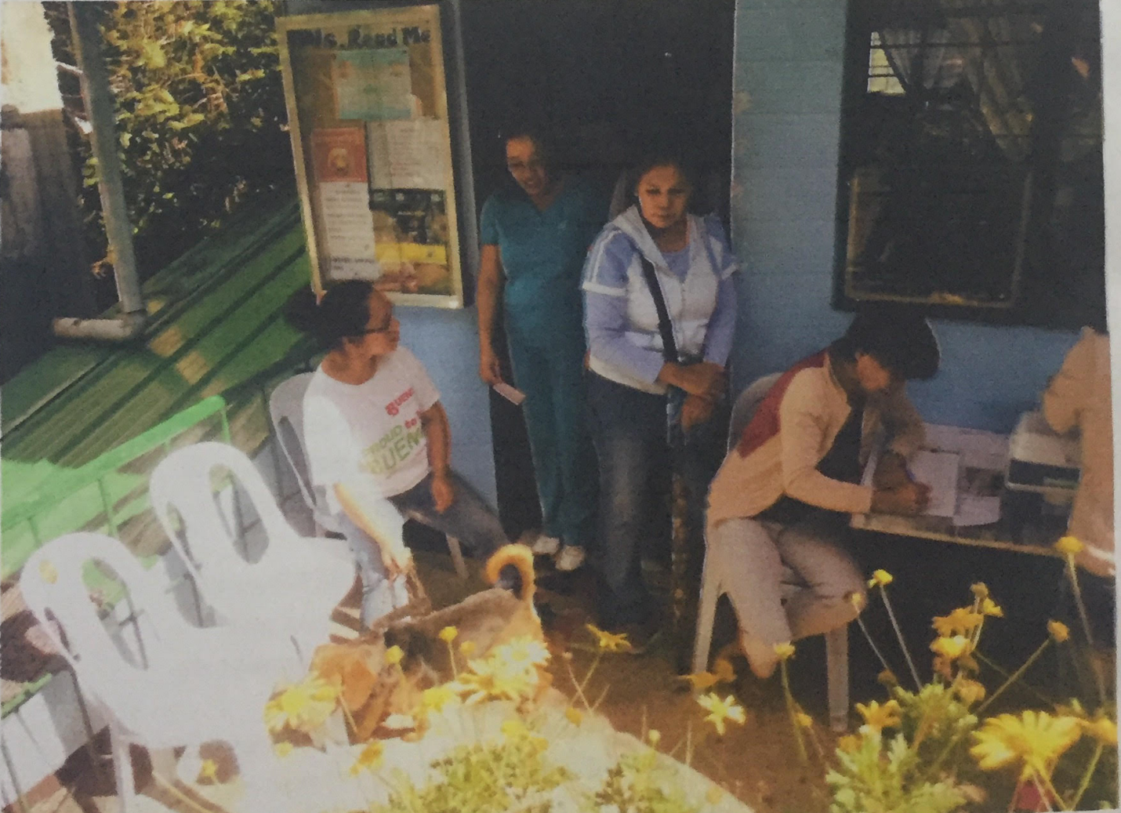

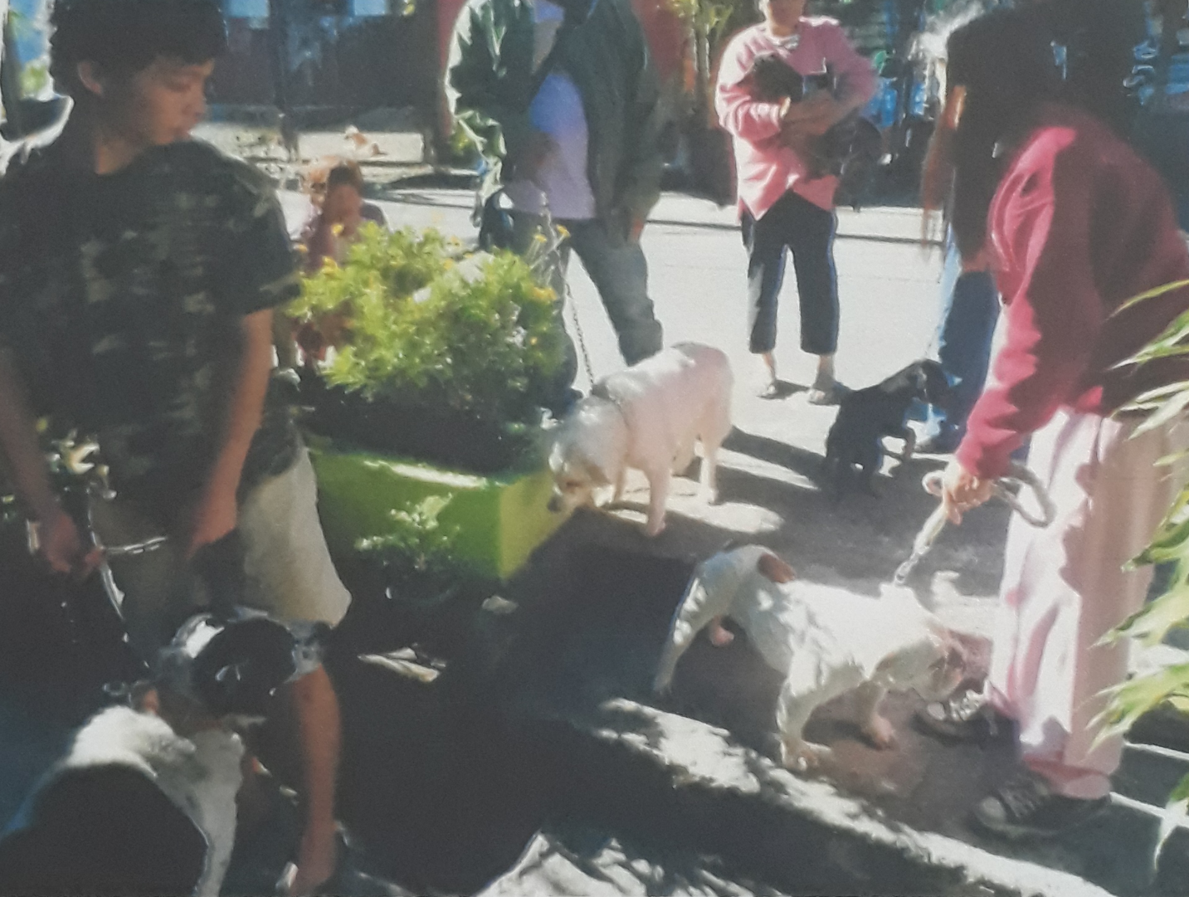

**Community Problems, Issues, and Concerns**

1. Land issues
2. Availment of city service (water and electric connection)
3. Garbage segregation
4. Health issues (Dengue, Mal-nutrition, Common Illness)
5. Peace and Order